Quant Research Meeting
Mar 27th, 2015 | Location: Conference Room
Agenda

- Project Status
  - Completed Projects
    - Completed preliminary version of new Yield Curve Builder with QuantLib. Curve consistency checks out and forward rates make sense. However, spot rates still seem nonsensical. (Neo)
    - Replaced old Scale (Scale_Legacy) with new one in the repository (Johnson)
    - Proxy for Pipeline Hedging Costs Report (Lien)
      - We use the Swaption Volatility and Realized Current Coupon Volatility for the Proxy.
      - The Realized Volatility is the annualized volatility of absolute return of current coupon. This volatility is calculated in an interval of 60 days.
    - Effective Guarantee Fees and Upfront Loan-Level Price Adjustments (Lien)
      - Use Fannie Mae single family effective g-fee rate and single-family average charged g-fee on new acquisitions data which is produced on Fannie Mae annual and quarterly SEC filing documents
      - Also shows Upfront Loan-Level Price Adjustments matrix
    - Origination Market Concentration report (Lien):
      - Completed VBA code for generating the daily report
      - Added issued volume for each originator
    - Primary market report progress (Lien):
      - Productionalized the daily report - set it up to be part of daily batch report run. The reports are posted in S:\Analytics\Primary Market\<yyyy>\<mm>
      - Added short term analysis
        - One Week Changes (bps) - Recent Two Months for Servicing Spread and FHLMC Survey Rate Report
        - One Month Changes - Recent 6 Month for Time from Refinancing Application to Funding Report
Those short term charts will help to capture the dynamic changes, and would be good supplement for the long term trend analysis.
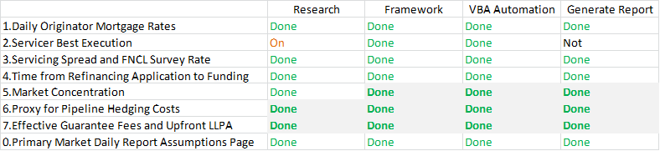
    - Research the hedged return for IOS+TBA (Lien)
      - Prepared the model input time series: return, index OAS, index realized carry, realized volatility, prepayment risk premium, yield curve slope

  - In Progress
    - Further validate curve construction from QuantLib (Neo)
    - Structurize the yield curve builder by following OOP design patterns (Neo)
    - Research the hedged return for IOS+TBA (Lien)
      - Do regression on the hedged return of the prediction parameters
      - Calculate z-score for the return
      - Optimize Sharpe Ratio by changing the investment percentage parameter K
    - Rewriting script for scrubbing Credit loan data (Raj)
    - Prepayment/Roll-rate reports (Raj)
Attendees

Derek Ho, Sharad Chaudhary, Neo Wang, Lien Chen, Robert Morris, Raj Savai, Johnson Ho

